|  |
| --- |
|  |
| qvantum – python module |
| Documentation |

|  |
| --- |
| Sohonyai, Ádám  2018.11.18. |

Contents

1 Introduction 2

2 Installing 2

2.1 pip install 2

2.2 wheel install 2

2.3 setup file 2

3 Module Classes 2

3.1 Qubit class 3

3.2 Register class 5

3.3 Gate class 10

3.4 Layer class 15

3.5 Circuit class 18

3.6 Bloch sphere functions 21

4 Examples 23

4.1 Quantum teleportation 23

4.2 Grover’s algorithm 24

5 Notes 27

5.1 Module reading error 27

5.2 Deleting a qubit from register 27

5.3 Ѱ sign in python2 28

# Introduction

qvantum is a python module with the goal to ensure an easy use library for understanding quantum computing better or designing new quantum algorithms. Working with this module helps you the get more familiar with the basic concepts such as qubit, register or quantum gate, meanwhile the tool has the power for deeper analysis and development.

The module is in beta release phase: tested but it might contain bugs, therefore every constructive note is highly welcomed. Also If you would like to collaborate in the developing process then do not hesitate and contact us.

# Installing

qvantum module can be easily installed using three different approach below.

## pip install

The latest version of the module can be installed online from the PyPi page using pip in command line:

pip install qvantum

or

python –m pip install qvantum

or

python -m pip install --index-url <https://test.pypi.org/simple/> qvantum

## wheel install

The latest version of the module can be downloaded from the PyPi page in .whl format which can be used for installation:

pip install qvantum-x.xx-py2.py3-none-any.whl

or

python –m pip install qvantum-x.xx-py2.py3-none-any.whl

## setup file

A setup.py file is also available on PyPi page. Download the file then run the command in the folder where the setup.py file was downloaded. Use –e if you want the module be immediately available for every user in your system:

pip install . (or pip install –e .)

or

python –m pip install . (python –m pip install –e .)

# Module Classes

In qvantum module there are some classes which represents the basic objects in quantum computing such as: a qubit, a register, a gate, a layer and a circuit. These objects (and therefore the classes which represents them) are built on each other. Due to this concept a register is built on qubits, layers are formed by gates and circuits are created out of gates.

There is a sixth class, the bloch class which is used for teh Bloch representation and visualisation of a qubit.

## Qubit class

In quantum computing a qubit or quantum bit is the basic unit of quantum information. Every qubit has two clear states such as 0 and 1 but unlike a classical bit a qubit can be in superposition which is a special mixture of these clear states.

An instance of the qubit class has these methodes below.

qvantum.Qubit.__init__(alpha, beta)

Method to initialize an instance of the qubit class. The squared sum of alpha and beta bust be equal to zero otherwise a ValueError will be thrown.

Parameters:

alpha: int, float or complex

beta: int, float or complex

Example:

import math

import qvantum

q = qvantum.Qubit(1, 0)

qvantum.Qubit(1 / math.sqrt(2), 1 / math.sqrt(2))

q = qvantum.Qubit(5, 2)

q = qvantum.Qubit(1, ’red’)

qvantum.Qubit(1, 0).show()

qvantum.Qubit.get_alpha()

Getter method of alpha.

Example:

import qvantum

q = qvantum.Qubit(1, 0)

q.get_apha()

qvantum.Qubit.get_beta()

Getter method of beta.

Example:

import qvantum

q = qvantum.Qubit(1, 0)

q.get_beta()

qvantum.Qubit.set_amplitudes(alpha, beta)

Setter method to replace the old coefficients to new ones. The squared sum of alpha and beta bust be equal to zero otherwise a ValueError will be thrown.

Parameters:

alpha: int, float or complex

beta: int, float or complex

Example:

import math

import qvantum

q = qvantum.Qubit(1, 0)

q.show()

q.set_amplitudes(0, 1)

q.show()

qvantum.Qubit.show()

This method shows the state function of the qubit object.

Example:

import qvantum

q = qvantum.Qubit(1, 0)

q.show()

qvantum.Qubit.measure()

This method performs a measurement on the qubit and returns with one clear state by the distribtion according to the coefficients.

Example:

import qvantum

q = qvantum.Random_Qubit()

q.show()

q.measure()

q.show()

qvantum.Qubit.ket()

This method returns with the ket vector representation of the qubit.

Example:

import qvantum

q = qvantum.Random_Qubit()

q.ket()

qvantum.Qubit.bra()

This method returns with the bra vector representation of the qubit.

Example:

import qvantum

q = qvantum.Random_Qubit()

q.bra()

qvantum.Random_Qubit.__init__()

This is an inhereted class from the Qubit class. They share the same methods but when an instance of the Random_Qubit class is created the coefficients are randomly choosen.

Example:

import qvantum

rq = qvantum.Random_Qubit()

rq.show()

qvantum.Random_Qubit().show()

qvantum.check_qubit.py

This is the decorator file and is used to check the arguments when a method is called with parameters.

## Register class

A system containing more than one qubit is called a register. The state function of a register is the superposition of the allowed states of the qubits. The number of possible states is increasing exponentially with every new qubit is added to the system.

An instance of the qubit class has these methodes below.

*qvantum.Register.__init__(qubit_list)*

Method to initialize an instance of the register class. The input is a list of elements in the Qubit or Random_Qubit class. Also this list must contain at least 2 elements.

Parameters:

qubit_list: list of element in Qubit or Random_Qubit class

Example:

import qvantum

q1 = qvantum.Random_Qubit()

q2 = qvantum.Random_Qubit()

r1 = qvantum.Register([q1])

r1 = qvantum.Register([q1, ’shoe’])

r1 = qvantum.Register({q1, q2})

r2 = qvantum.Register([q1, q2])

r2.show()

qvantum.Register.get_coeff_list()

This method returns the coefficients of the qubits in the regsiter.

Example:

import qvantum

q1 = qvantum.Random_Qubit()

q1.show()

q2 = qvantum.Random_Qubit()

q2.show()

r = qvantum.Register([q1, q2])

r.get_coeff_list()

qvantum.Register.get_state_number()

This method returns the number of the possible clear states for the register.

Example:

import qvantum

q1 = qvantum.Random_Qubit()

q2 = qvantum.Random_Qubit()

r = qvantum.Register([q1, q2])

r.show()

r.get_state_number()

qvantum.Register.get_qubit_number()

This method returns the number of the qubits in the register.

Example:

import qvantum

q1 = qvantum.Random_Qubit()

q2 = qvantum.Random_Qubit()

r = qvantum.Register([q1, q2])

r.show()

r.get_qubit_number()

qvantum.Register.get_states(nth=None)

This method returns with the n-th possible state for the regsiter if the parameter is definit. If it isn’t then the return value is the list of all possible states.

Parameters:

nth: int, None

Example:

import qvantum

q1 = qvantum.Random_Qubit()

q2 = qvantum.Random_Qubit()

r = qvantum.Register([q1, q2])

r.show()

r.get_states(6)

r.get_states(’red’)

r.get_states(2)

qvantum.Register.get_amplitudes(nth=None)

This method returns with the coefficient of the n-th possible state for the regsiter if the parameter is definit. If it isn’t then the return value is the list of the coefficients of all possible states.

Parameters:

nth: int, None

Example:

import qvantum

q1 = qvantum.Random_Qubit()

q2 = qvantum.Random_Qubit()

r = qvantum.Register([q1, q2])

r.show()

r.get_amplitudes(6)

r.get_amplitudes(’red’)

r.get_amplitudes(2)

qvantum.Register.set_amplitudes(amp_list)

This method sets new coefficients for the possible states of the register. The input parameter is a list of real or complex number and their squared sum must be equal to 1. Number of elements in the least must be equal with the number of possible states.

Parameters:

amp_list: list of int, float or complex

Example:

import qvantum

q1 = qvantum.Random_Qubit()

q2 = qvantum.Random_Qubit()

q3 = qvantum.Random_Qubit()

r = qvantum.Register([q1, q2, q3])

r.show()

r.set_amplitudes([0, 0, 1, 0, 0, 0, 0, 0])

r.show()

*qvantum.Register.show()*

This method shows the state function of the register object.

Example:

import qvantum

q1 = qvantum.Random_Qubit()

q2 = qvantum.Random_Qubit()

q3 = qvantum.Random_Qubit()

r = qvantum.Register([q1, q2, q3])

r.show()

*qvantum.Register.measure_register()*

This method performs a measurement on the whole register and returns the final state of the register after the process. This final state is randomized regarding to the amplitudes of the register.

Example:

import qvantum

q1 = qvantum.Random_Qubit()

q2 = qvantum.Random_Qubit()

q3 = qvantum.Random_Qubit()

r = qvantum.Register([q1, q2, q3])

r.show()

r.measure_register()

r.show()

*qvantum.Register.measure_nth_qubit(nth)*

This method performs a measurement on the n-th qubit in the register and returns the final state of the register after the process. This final state is randomized regarding to the amplitudes of the register. The input parameter must be an integer corresponding to the number of qubits in the register.

Parameters:

nth: int

Example:

import qvantum

q1 = qvantum.Random_Qubit()

q2 = qvantum.Random_Qubit()

q3 = qvantum.Random_Qubit()

r = qvantum.Register([q1, q2, q3])

r.show()

r.measure_nth_qubit(3)

r.measure_nth_qubit(’red’)

r.measure_nth_qubit(2)

r.show()

qvantum.Register.ket()

This method returns with the ket vector representation of the register.

Example:

import qvantum

q1 = qvantum.Random_Qubit()

q2 = qvantum.Random_Qubit()

r = qvantum.Register([q1, q2])

r.show()

r.ket()

qvantum.Register.bra()

This method returns with the bra vector representation of the register.

Example:

import qvantum

q1 = qvantum.Random_Qubit()

q2 = qvantum.Random_Qubit()

r = qvantum.Register([q1, q2])

r.show()

r.bra()

qvantum.Regsiter.delete_qubit(nth)

This method deletes the n-th qubit from the regsiter. This method has some drawback, for more information see section 5.2 The input parameter must be an integer corresponding to the number of qubits in the register.

Parameters:

nth: int

Example:

q1 = qvantum.Random_Qubit()

q2 = qvantum.Random_Qubit()

q3 = qvantum.Random_Qubit()

r = qvantum.Register([q1, q2, q3])

r.show()

r.delete_qubit(3)

r.delete_qubit()

r.delete_qubit(1)

r.show()

qvantum.Register.insert_qubit(q, nth)

This method inserts a given qubit into a register. The input parameter must be an integer corresponding to the number of qubits in the register.

Parameters:

q: Qubit or Random_Qubit

nth: int

Example:

import qvantum

q1 = qvantum.Random_Qubit()

q2 = qvantum.Random_Qubit()

r = qvantum.Register([q1, q2])

r.show()

q3 = qvantum.Random_Qubit()

r.insert_qubit(q3, 3)

r.insert_qubit(, 2)

r.insert_qubit(’red’, 2)

r.insert_qubit(q3, 2)

r.show()

r.insert_qubit(q3, 2)

r.show()

qvantum.check_register.py

This is the decorator file and is used to check the arguments when a method is called with parameters.

## Gate class

Quantum logic gates are the basic building blocks of quantum circuits. They are operating on a few number of qubits. Quantum gates have the same function as classical logical gates in digital circuits. Every quantum gate is represented as an unitary matrix moreover every unitary matrix can be used as a quantum logic gate.

*qvantum.Gate.__init__()*

This method initialize a 2x2 sized identity matrix. Every identity matrix is a unitary matrix as well.

Example:

import qvantum

G = qvantum.Gate()

G.get_name()

G.get_matrix()

G.get_size()

*qvantum.Gate.__call__(qr)*

This method makes possible to call a gate on a qubit or a register. The only restriction is the size of the gate and the size of the qubit or regsiter must be equal to each other.

Parameters:

qr: Qubit, Random_Qubit or Register

Example:

import qvantum

q = qvantum.Random_Qubit()

q.show()

qvantum.Hadamard(q)

q.show()

*qvantum.Gate.get_name()*

This method retuns the name of the gate.

Example:

import qvantum

h = qvantum.Hadamard()

h.get_name()

*qvantum.Gate.get_matrix()*

This method retuns the unitary matrix of the gate.

Example:

import qvantum

c = qvantum.CNOT()

c.get_matrix()

*qvantum.Gate.get_size()*

This method retuns the size of the unitary matrix of the gate.

Example:

import qvantum

t = qvantum.Toffoli()

t.get_size()

*qvantum.Gate.set_name(name)*

This method sets a new name for the gate.

Parameters:

name: string

Example:

import qvantum

h = qvantum.Hadamard()

h.get_name()

h.set_name(’New Hadamard’)

h.get_name()

*qvantum.Gate.set_matrix(matrix)*

This method sets a new unitary matrix for the gate. If matrix is not unitary then an error is raised.

Parameters:

matrix: numpy.ndarray

Example:

import numpy

import qvantum

g = qvantum.Gate()

g.get_matrix()

g.set_matrix(numpy.matrix([

[1 / numpy.sqrt(2), 1 / numpy.sqrt(2)],

[1 / numpy.sqrt(2), -1 / numpy.sqrt(2)]

]))

g.get_matrix()

*qvantum.Gate.power(power)*

This method raises the unitary matrix of the gate to the given power and overwrites the original matrix of the gate with the results matrix.

Parameters:

power: int

Example:

import qvantum

t = qvantum.Toffoli()

t.get_matrix()

t.power(2.1)

t.power(3)

t.get_matrix()

*qvantum.Hadamard()*

This class is an inherited class from the Gate class. It’s the implementation of the Hadamard gate. Its unitary matrix looks like this:

*qvantum.SquareNot()*

This class is an inherited class from the Gate class. It’s the implementation of the Square-Not gate. Its unitary matrix looks like this:

*qvantum.PauliX()*

This class is an inherited class from the Gate class. It’s the implementation of the Pauli-X gate. Its unitary matrix looks like this:

*qvantum.PauliY()*

This class is an inherited class from the Gate class. It’s the implementation of the Pauli-Y gate. Its unitary matrix looks like this:

*qvantum.PauliZ()*

This class is an inherited class from the Gate class. It’s the implementation of the Pauli-Z gate. Its unitary matrix looks like this:

*qvantum.Phase()*

This class is an inherited class from the Gate class. It’s the implementation of the Phase gate. Its unitary matrix looks like this:

*qvantum.Pi8()*

This class is an inherited class from the Gate class. It’s the implementation of the Pi8 gate. Its unitary matrix looks like this:

*qvantum.Swap()*

This class is an inherited class from the Gate class. It’s the implementation of the Swap gate. Its unitary matrix looks like this:

*qvantum.SquareSwap()*

This class is an inherited class from the Gate class. It’s the implementation of the Square-Swap gate. Its unitary matrix looks like this:

*qvantum.CNOT(control_qubit, target_qubit)*

This class is an inherited class from the Gate class. It’s the implementation of the Controlled-Not gate. It’s called on 2 qubits. The parameters determine which one is the control and the target – (0, 1) or (1, 0)

Parameters:

control_qubit: 0, 1

target_qubit: 0, 1

Its unitary matrix looks like this – (0, 1) or (1, 0):

or

*qvantum.ControlledZ()*

This class is an inherited class from the Gate class. It’s the implementation of the Controlled-Z gate. Its unitary matrix looks like this:

*qvantum.ControlledPhase()*

This class is an inherited class from the Gate class. It’s the implementation of the Controlled-Phase gate. Its unitary matrix looks like this:

*qvantum.Ising(phi)*

This class is an inherited class from the Gate class. It’s the implementation of the Ising gate.

Parameters:

phi: int, float

Its unitary matrix looks like this:

*qvantum.Toffoli(target_qubit)*

This class is an inherited class from the Gate class. It’s the implementation of the Toffoli gate. It’s called on 3 qubits. The parameters determine which one is the target qubit – 0, 1 or 2.

Parameters:

target_qubit: 0, 1, 2

Its unitary matrix looks like this (target qubit – 0, 1 or 2):

or or

*qvantum.Fredkin(control_qubit)*

This class is an inherited class from the Gate class. It’s the implementation of the Fredkin gate. It’s called on 3 qubits. The parameters determine which one is the control qubit – 0, 1 or 2.

Parameters:

control_qubit: 0, 1, 2

Its unitary matrix looks like this (control qubit – 0, 1 or 2):

or or

qvantum.check_gate.py

This is the decorator file and is used to check the arguments when a method is called with parameters.

## Layer class

Every register and quantum gate are organised into layers and these layers are the building blocks of a given quantum circuit. A layer is a representation of one stage in a current quantum computational process.

*qvantum.Layer.__init__(gate_list)*

This method initializes an instance of the Layer class. The argument must be a list of objects in the Gate class or in an inherited class such as: Hadamard, SquareNot, PauliX, PauliY, PauliZ, Phase, Pi8, Swap, SquareSwap, CNOT, ControlledZ, ControlledPhase, Ising, Toffoli, Fredkin

Parameters:

gate_list: list

Example:

import qvantum

l1 = qvantum.Layer([qvantum.Hadamard(), qvantum.Gate()])

l1.get_gate_list()

l2 = qvantum.Layer([qvantum.CNOT()])

l2.get_layer_matrix()

*qvantum.Layer.get_gate_list()*

This method returns the gates which are contained by the current Layer object.

Example:

import qvantum

l = qvantum.Layer([qvantum.Hadamard(), qvantum.Gate()])

l.get_gate_list()

*qvantum.Layer.get_gate_number()*

This method returnd the number of the gates which are contained by the current Layer object.

Example:

import qvantum

l = qvantum.Layer([qvantum.Hadamard(), qvantum.Gate()])

l.get_gate_number()

*qvantum.Layer.get_nth_gate(nth)*

This method returns the n-th gate in the current Layer object. The parameter must be between 0 and the actual number of the gates.

Parameters:

nth: int

Example:

import qvantum

l = qvantum.Layer([qvantum.Hadamard(), qvantum.Gate()])

l.get_nth_gate(2)

l.get_nth_gate(0)

l.get_nth_gate(1)

*qvantum.Layer.get_layer_matrix()*

This method returns the result of the Kronecker multiplication of the gates’ matrices which are contained by the current Layer object. When the Layer is applied on a Register during one step of a calculation the state vector of the Register is multiplied by this matrix.

Example:

import qvantum

l = qvantum.Layer([qvantum.Hadamard(), qvantum.Gate()])

l.get_layer_matrix()

*qvantum.Layer.get_matrix_size()*

This method returns the size of the matrix of the current Layer object.

Example:

import qvantum

l = qvantum.Layer([qvantum.Hadamard(), qvantum.Gate()])

l.get_layer_matrix()

l.get_matrix_size()

*qvantum.Layer.get_layer_size()*

This method returns the size of the current Layer object. Remember, it’s not the size of the matrix of the current Layer object but the size of a Register object which the Layer can be applied on.

Example:

import qvantum

l = qvantum.Layer([qvantum.Hadamard(), qvantum.Gate()])

l.get_layer_matrix()

l.get_matrix_size()

l.get_layer_size()

*qvantum.Layer.delete_gate(nth)*

This method deletes the n-th gate from the current Layer object. The parameter must be equal to or bigger than 0 and less than the actual size of the Layer.

Parameters:

nth: int

Example:

import qvantum

l = qvantum.Layer([qvantum.Hadamard(), qvantum.Gate(), qvantum.CNOT()])

l.get_gate_list()

l.delete_gate(3)

l.delete_gate(0)

l.get_gate_list()

*qvantum.Layer.insert_gate(g, nth)*

This method inserts a Gate object into the n-th place in the current Layer object. The first parameter must be a Gate object or an object in an inherited class such as: Hadamard, SquareNot, PauliX, PauliY, PauliZ, Phase, Pi8, Swap, SquareSwap, CNOT, ControlledZ, ControlledPhase, Ising, Toffoli, Fredkin. The second parameter must be equal to or bigger than 0 and equal to or less than the actual size of the Layer.

Parameters:

g: Gate, Hadamard, SquareNot, PauliX, PauliY, PauliZ, Phase, Pi8, Swap, SquareSwap, CNOT, ControlledZ, ControlledPhase, Ising, Toffoli, Fredkin

nth: int

Example:

import qvantum

l = qvantum.Layer([qvantum.Hadamard(), qvantum.Gate(), qvantum.CNOT()])

l.get_gate_list()

l.insert_gate(4)

l.insert_gate(1)

l.get_gate_list()

l.insert_gate(4)

l.get_gate_list()

qvantum.check_layer.py

This is the decorator file and is used to check the arguments when a method is called with parameters.

## Circuit class

A quantum circuit is a representation of a quantum algorithm. It’s built by layers and the computational process of the circuit is ran on a quantum register as the input.

*qvantum.Circuit.__init__()*

This method initializes an instance of the Circuit class. The argument must be a list of objects in the Layer class with the same size.

Parameters:

layer_list: list

Example:

import qvantum

l1 = qvantum.Layer([qvantum.Hadamard(), qvantum.Gate()])

l2 = qvantum.Layer([qvantum.CNOT()])

c = qvantum.Circuit([l1, l2])

c.get_layer_list()

c.get_nth_layer(0)

*qvantum.Circuit.get_layer_list()*

This method returns the layers which are contained by the current Circuit object.

Example:

import qvantum

l1 = qvantum.Layer([qvantum.Hadamard(), qvantum.Gate()])

l2 = qvantum.Layer([qvantum.CNOT()])

c = qvantum.Circuit([l1, l2])

c.get_layer_list()

*qvantum.Circuit.get_layer_number()*

This method returnd the number of the layers which are contained by the current Circuit object.

Example:

import qvantum

l1 = qvantum.Layer([qvantum.Hadamard(), qvantum.Gate()])

l2 = qvantum.Layer([qvantum.CNOT()])

c = qvantum.Circuit([l1, l2])

c.get_layer_number()

*qvantum.Circuit.get_nth_layer(nth)*

This method returns the n-th layer in the current Circuit object. The parameter must be between 0 and the actual number of the layers.

Parameters:

nth: int

Example:

import qvantum

l1 = qvantum.Layer([qvantum.Hadamard(), qvantum.Gate()])

l2 = qvantum.Layer([qvantum.CNOT()])

c = qvantum.Circuit([l1, l2])

c.get_layer_list()

c.get_nth_layer(2)

c.get_nth_layer(1)

*qvantum.Circuit.get_circuit_size()*

This method returns the size of the current Circuit object. It’s the size of the Register object which the Circuit can be applied on.

Example:

import qvantum

l1 = qvantum.Layer([qvantum.Hadamard(), qvantum.Gate()])

l2 = qvantum.Layer([qvantum.CNOT()])

c = qvantum.Circuit([l1, l2])

c.get_layer_list()

c.get_circuit_size()

*qvantum.Circuit.delete_layer(nth)*

This method deletes the n-th layer from the current Circuit object. The parameter must be equal to or bigger than 0 and less than the actual number of the layers in the Circuit.

Parameters:

nth: int

Example:

import qvantum

l1 = qvantum.Layer([qvantum.Hadamard(), qvantum.Gate()])

l2 = qvantum.Layer([qvantum.CNOT()])

c = qvantum.Circuit([l1, l2])

c.get_layer_list()

c.delete_layer(2)

c.delete_layer(0)

c.get_layer_list()

*qvantum.Circuit.insert_layer(l, nth)*

This method inserts a Layer object into the n-th place in the current Circuit object. The first parameter must be a Layer object while the second parameter must be equal to or bigger than 0 and equal to or less than the actual size of the layers in the Circuit. The size of the Layer object must be equal to the size of the already used Layers in the Circuit.

Parameters:

l: Layer

nth: int

Example:

import qvantum

l1 = qvantum.Layer([qvantum.Hadamard(), qvantum.Gate()])

l2 = qvantum.Layer([qvantum.CNOT()])

c = qvantum.Circuit([l1, l2])

c.get_layer_list()

l3 = qvantum.Layer([qvantum.Swap()])

c.insert_layer(3)

c.delete_layer(1)

c.get_layer_list()

*qvantum.Circuit.run(r)*

This method performs the computational process on a Register object as input and returns the result. The size of the Register object and the size of the Circuit object must be equal.

Parameters:

r: Register

Example:

import qvantum

q1 = qvantum.Random_Qubit()

q2 = qvantum.Random_Qubit()

r = qvantum.Register([q1, q2])

r.show()

l1 = qvantum.Layer([qvantum.Hadamard(), qvantum.Gate()])

l2 = qvantum.Layer([qvantum.CNOT()])

c = qvantum.Circuit([l1, l2])

c.run(r)

r.show()

qvantum.check_circuit.py

This is the decorator file and is used to check the arguments when a method is called with parameters.

## Bloch sphere functions

The Bloch sphere is a geometrical representation of the pure state space of a qubit so the puprose of this class to make possible to visualize a qubit and easily switch between the Bloch coordinates and the representation by coefficients of a quantum state.

*qvantum.bloch_coords()*

This function calculates the coordinates of the Bloch representation from the state vector of a Qubit object.

Parameters:

q: Qubit or Random_Qubit

Example:

import qvantum

q = qvantum.Random_Qubit()

qvantum.bloch_coords(q)

*qvantum.bloch_qubit()*

This function calculates the state vector of a Qubit object from the given Bloch coordinates.

Parameters:

u: int, float

v: int, float

w: int, float

Example:

import math

import qvantum

u = 0

v = 1/math.sqrt(2)

w = 1/math.sqrt(2)

qvantum.bloch_qubit(u, v, w)

*qvantum.phase_test(c1, c2)*

Computes the phase between two complex number.

Parameters:

c1: complex

c2: complex

Example:

import qvantum

q1 = qvantum.Random_Qubit()

q2 = qvantum.bloch_qubit(qvantum.bloch_coords(q))

qvantum.phase_test(q1.get_alpha(), q2.get_alpha())

qvantum.phase_test(q1.get_beta(), q2.get_beta())

*qvantum.bloch_sphere_plot(u, v, w, xfigsize=None, yfigsize=None, frame_on=None, tight_layout_on=None, style=None, surface_on=None, wireframe_on=None, surface_cmap=None, surface_alpha=None, wireframe_color=None, wireframe_linewidth=None, quiver_color=None, quiver_linewidth=None, quiver_ratio=None, line_color=None, line_linewidth=None, circle_edgecolor=None, circle_facecolor=None, circle_linewidth=None )*

This function visualizes the qubit using its bloch coordinates.

Parameters (with default values):

xfigsize = 15

yfigsize = 7.5

frame_on = False

tight_layout_on = True

style = 'dark_background'

surface_on = True

wireframe_on = True

surface_cmap = 'Blues_r'

surface_alpha = 0.3

wireframe_color = '#d3d3d3'

wireframe_linewidth = 0.075

quiver_color = '#ffffff'

quiver_linewidth = 1.5

quiver_ratio = 0.1

line_color = '#d3d3d3'

line_linewidth = 0.3

circle_edgecolor = '#d3d3d3'

circle_facecolor = 'none'

circle_linewidth = 0.3

Example:

import qvantum

q = qvantum.Random_Qubit()

u = qvantum.bloch_coords(q)[0]

v = qvantum.bloch_coords(q)[1]

w = qvantum.bloch_coords(q)[2]

qvantum.bloch_sphere_plot(u, v, w)

# Examples

The examples in this section show the way how to interpret the already known quantum circuits or develop new ones using the qvantum module.

## Quantum teleportation

The quantum circuit of teleportation looks like this below:

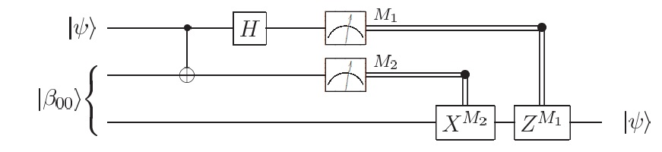(Source: Michael A. Nielsen & Isaac L. Chuang - Quantum Computation and Quantum Information)

And the same circuit can be represented this way by using qvantum module:

import qvantum

q = qvantum.Random_Qubit()

q1 = qvantum.Qubit(1, 0)

q2 = qvantum.Qubit(1, 0)

r = qvantum.Register([q1, q2])

l0 = qvantum.Layer([qvantum.Hadamard(), qvantum.Gate()])

l1 = qvantum.Layer([qvantum.CNOT(0, 1)])

c0 = qvantum.Circuit([l0, l1])

c0.run(r)

r.insert_qubit(q, 0)

l2 = qvantum.Layer([qvantum.CNOT(0, 1), qvantum.Gate()])

l3 = qvantum.Layer([qvantum.Hadamard(), qvantum.Gate(), qvantum.Gate()])

c1 = qvantum.Circuit([l2, l3])

c1.run(r)

m0 = r.measure_nth_qubit(0)

m1 = r.measure_nth_qubit(1)

XM2 = qvantum.PauliX()

XM2.power(m1)

ZM1 = qvantum.PauliZ()

ZM1.power(m0)

l4 = qvantum.Layer([qvantum.Gate(), qvantum.Gate(), XM2])

l5 = qvantum.Layer([qvantum.Gate(), qvantum.Gate(), ZM1])

c2 = qvantum.Circuit([l4, l5])

c2.run(r)

r.delete_qubit(0)

r.delete_qubit(0)

q.show()

r.show()

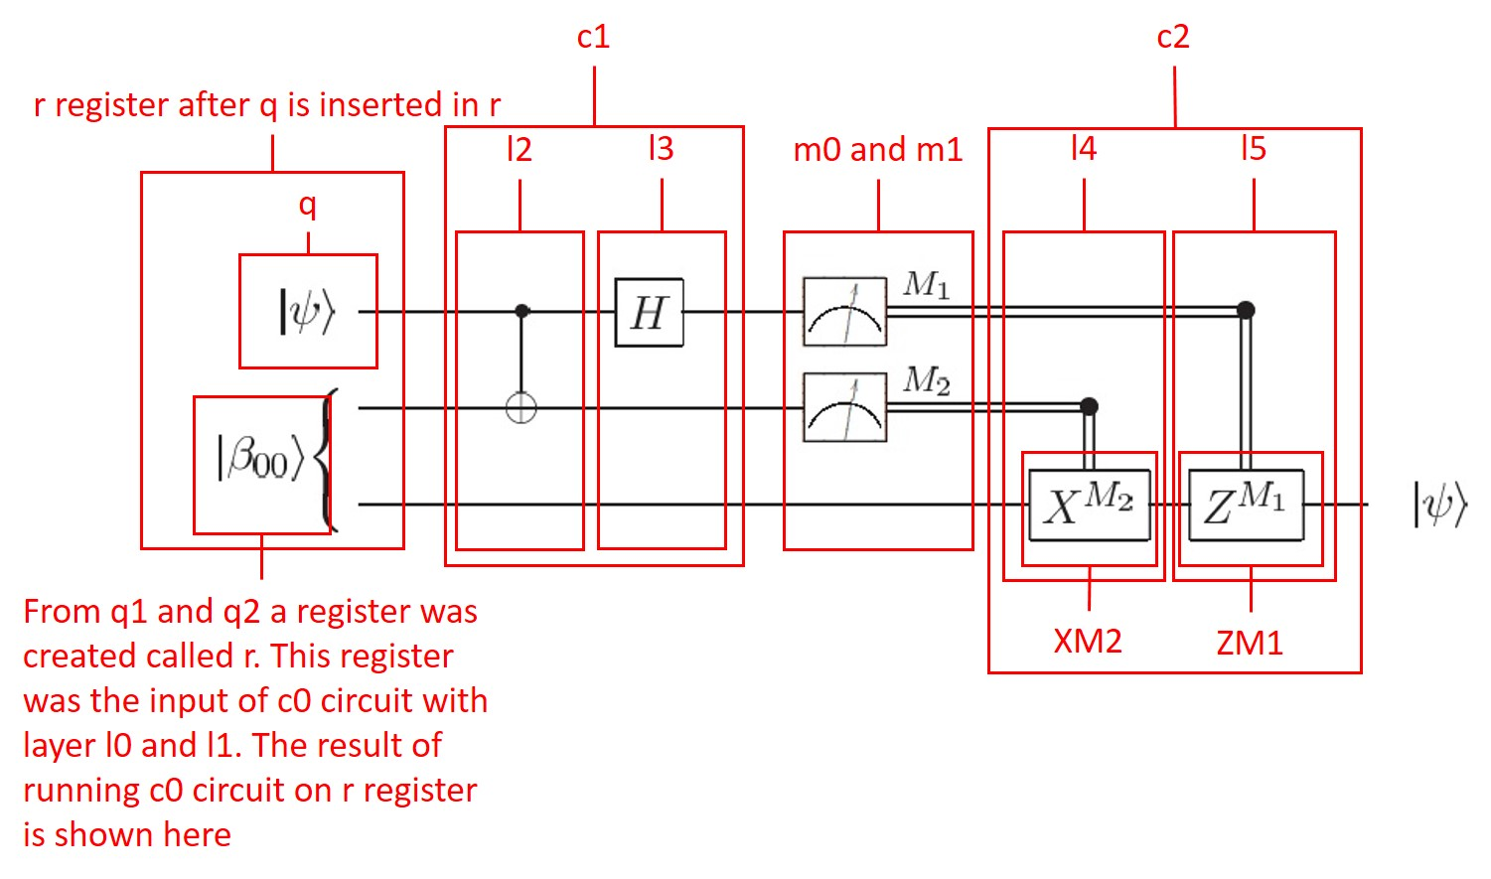

## Grover’s algorithm

The implementations of Grover’s search for number 5 is looks like this below, first the original circuit:

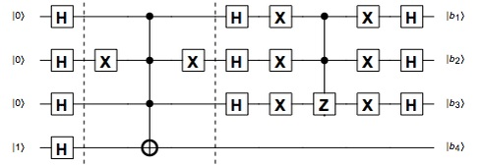

(Source: http://demonstrations.wolfram.com/QuantumCircuitImplementingGroversSearchAlgorithm/)

And this is the solution using qvantum module:

import numpy

import qvantum

q0 = qvantum.Qubit(1, 0)

q1 = qvantum.Qubit(1, 0)

q2 = qvantum.Qubit(1, 0)

q3 = qvantum.Qubit(0, 1)

r = qvantum.Register([q0, q1, q2, q3])

r.show()

l0 = qvantum.Layer([qvantum.Hadamard(), qvantum.Hadamard(), qvantum.Hadamard(), qvantum.Hadamard()])

l1 = qvantum.Layer([qvantum.Gate(), qvantum.PauliX(), qvantum.Gate(), qvantum.Gate()])

g2 = qvantum.Gate()

g2.set_matrix(numpy.matrix([

[1, 0, 0, 0, 0, 0, 0, 0, 0, 0, 0, 0, 0, 0, 0, 0],

[0, 1, 0, 0, 0, 0, 0, 0, 0, 0, 0, 0, 0, 0, 0, 0],

[0, 0, 1, 0, 0, 0, 0, 0, 0, 0, 0, 0, 0, 0, 0, 0],

[0, 0, 0, 1, 0, 0, 0, 0, 0, 0, 0, 0, 0, 0, 0, 0],

[0, 0, 0, 0, 1, 0, 0, 0, 0, 0, 0, 0, 0, 0, 0, 0],

[0, 0, 0, 0, 0, 1, 0, 0, 0, 0, 0, 0, 0, 0, 0, 0],

[0, 0, 0, 0, 0, 0, 1, 0, 0, 0, 0, 0, 0, 0, 0, 0],

[0, 0, 0, 0, 0, 0, 0, 1, 0, 0, 0, 0, 0, 0, 0, 0],

[0, 0, 0, 0, 0, 0, 0, 0, 1, 0, 0, 0, 0, 0, 0, 0],

[0, 0, 0, 0, 0, 0, 0, 0, 0, 1, 0, 0, 0, 0, 0, 0],

[0, 0, 0, 0, 0, 0, 0, 0, 0, 0, 1, 0, 0, 0, 0, 0],

[0, 0, 0, 0, 0, 0, 0, 0, 0, 0, 0, 1, 0, 0, 0, 0],

[0, 0, 0, 0, 0, 0, 0, 0, 0, 0, 0, 0, 1, 0, 0, 0],

[0, 0, 0, 0, 0, 0, 0, 0, 0, 0, 0, 0, 0, 1, 0, 0],

[0, 0, 0, 0, 0, 0, 0, 0, 0, 0, 0, 0, 0, 0, 0, 1],

[0, 0, 0, 0, 0, 0, 0, 0, 0, 0, 0, 0, 0, 0, 1, 0],

]))

l2 = qvantum.Layer([g2])

l3 = qvantum.Layer([qvantum.Gate(), qvantum.PauliX(), qvantum.Gate(), qvantum.Gate()])

l4 = qvantum.Layer([qvantum.Hadamard(), qvantum.Hadamard(), qvantum.Hadamard(), qvantum.Gate()])

l5 = qvantum.Layer([qvantum.PauliX(), qvantum.PauliX(), qvantum.PauliX(), qvantum.Gate()])

g6 = qvantum.Gate()

g6.set_matrix(numpy.matrix([

[1, 0, 0, 0, 0, 0, 0, 0],

[0, 1, 0, 0, 0, 0, 0, 0],

[0, 0, 1, 0, 0, 0, 0, 0],

[0, 0, 0, 1, 0, 0, 0, 0],

[0, 0, 0, 0, 1, 0, 0, 0],

[0, 0, 0, 0, 0, 1, 0, 0],

[0, 0, 0, 0, 0, 0, 1, 0],

[0, 0, 0, 0, 0, 0, 0, -1]

]))

l6 = qvantum.Layer([g6, qvantum.Gate()])

l7 = qvantum.Layer([qvantum.PauliX(), qvantum.PauliX(), qvantum.PauliX(), qvantum.Gate()])

l8 = qvantum.Layer([qvantum.Hadamard(), qvantum.Hadamard(), qvantum.Hadamard(), qvantum.Gate()])

c = qvantum.Circuit([l0, l1, l2, l3, l4, l5, l6, l7, l8])

c.run(r)

r.show()

r.measure_nth_qubit(3)

r.delete_qubit(3)

r.show()

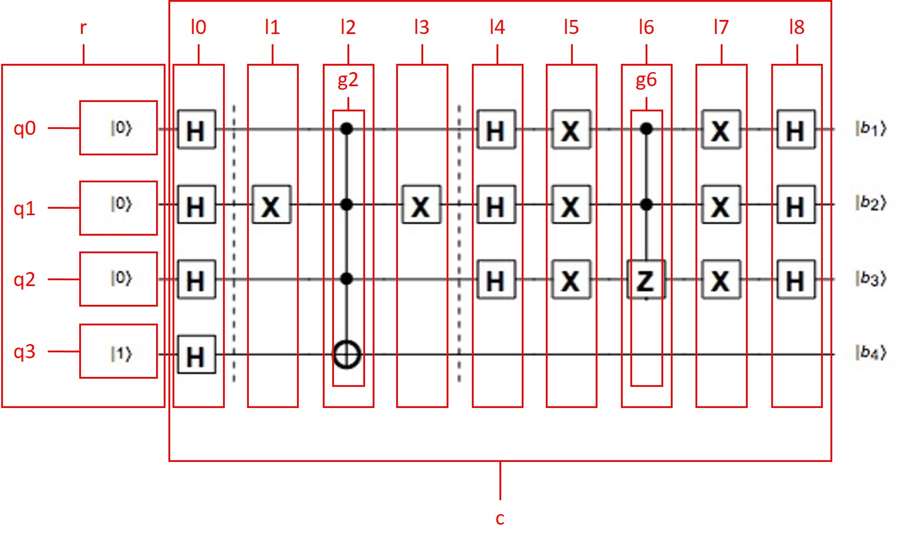

# Notes

## Module reading error

If there is some error after the installation of the module then it’s possible that there is some missconfiguration in the local variable parameters. In that case try to load the module using the actual path in the local system

import sys

sys.path.append(’path\to\your\module’)

import qvantum

## Deleting a qubit from register

it is possible that using the delete method of an object of the Register class the result is not what was expected. It’s because in quantum mechanics there are states which are cannot be described by the product of two different quantum states. This states are called quantum entanglement. Please be careful during using this method. Developing alternative ways to come over this problem is in progress.

## Ѱ sign in python2

Using python2, the state symbol Ѱ may not be displayed correctly. Unfortunatley this problem can not be solved on just the code level, the display also depends on the current local system parameters. Try to modify that if you encounter this problem.